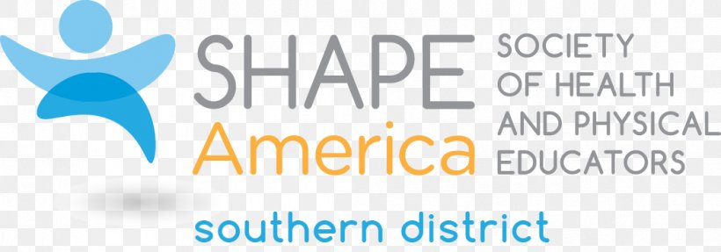
Innovate - Collaborate - Rejuvenate : Adapting and Evolving as an HPE Community

2020-2021 Southern District Action Plan
SHAPE America Vision:
A nation where all children are prepared to lead healthy, physically active lives.

SHAPE America Mission:
To advance professional practice and promote research related to health and physical education, physical activity, dance and sport.

SHAPE America Strategic Direction:
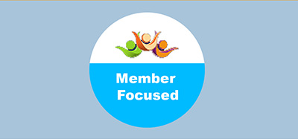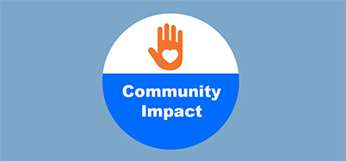
Foster a Strong, Well-Represented  Membership Community  Provide accessible standards- and high-quality resources and opportunities that serve current members’ needs and engage, empower and celebrate members.  Foster greater equity, diversity and inclusion within our community – and within our membership leadership opportunities.  Serve as the leading national voice and authority for all HPE advocacy and public policy and ensure the HPE community is well-equipped to advocate. | Build Community and Serve Students Through Meaningful Service-Learning and Give-Back Programs  Provide resources that connect physical health with mental health and help build wellness-oriented, EDI-focused schools.  Expand programs to serve more students and communities while also growing membership.  Provide opportunities — and support — for teachers to advocate for HPE. | Be the Voice for National Standards and High-Quality Professional Development  Engage the broader, diverse SHAPE America higher education community to promote research and to ensure tomorrow’s teachers are fully equipped to teach.  Expand programs to serve more students and communities while also growing membership.  Provide high-quality, standards- and skills based professional development opportunities that are inclusive and accessible, and which address key topics, including: equity, diversity and inclusion, social justice, assessment, physical literacy, and SEL.

SHAPE-Southern Mission:

The mission of SHAPE Southern District is to provide programs, products and services that support the efforts of health and physical education professionals charged with the promotion of healthy, active lifestyles.

SHAPE Southern District Goals

What do we want to accomplish as it relates to advancing SHAPE America’s mission?
What activities or efforts will we undertake this year?

Goal 1: Southern District Equity/Diversity/Inclusion

What is your timeline for any activities or efforts?
July 2020 - June 2021

Who will be responsible for undertaking them?
Southern District Leadership Council, Awards Committee, Nominations Committee

What SHAPE America staffing or fiscal resources will be required?
SHAPE America EDI Task Force support and resources

How will you define success regarding the activities or efforts your District undertakes this year?
We will define success in the area of EDI by encouraging Southern District states to consider EDI when nominating people for awards and leadership positions.

Success will also be defined if award recipients selected represent EDI.

SHAPE America Equity, Diversity and Inclusion Blogs:

The A-Z of Social Justice in Physical Education: Part 1 Shrehan Lynch - May, 2020

Reflections on Equity Diversity and Inclusion John Strong - October, 2019

All Students Need Safe, Supportive Spaces Stephanie Morris - January, 2019

Strengthening Our Commitment to EDI Stephanie Morris - December, 2018

Social Justice in Physical Education Shrehan Lynch and Dillon Landi - September, 2018

Equity, Diversity and Inclusion in HPE Stephanie Morris - September, 2018

Goal 2 : Southern District Professional Development-
HPE Re-Entry and Virtual Learning Support

What is your timeline for any activities or efforts?
Southern District was not given this Plan of Action until after schools had re-entered the 2020-2021 school year.
September 2020 Virtual Future Professional Leadership Development Conference
Who will be responsible for undertaking them?
Chair of FP LDC

What SHAPE America staffing or fiscal resources will be required?
SHAPE America website re-entry strategies and resources

How will you define success regarding the activities or efforts your District undertakes this year?
Each Southern District state registers at least one Future Professional for the virtual conference

Goal 3 : Southern District Advocacy and Communications

What is your timeline for any activities or efforts?
July 2020-June 2021
Plan and conduct State Advisory Report Zoom meeting July 2020-June 2021
Communicate with state Executive Directors and leaders on topics such as state conferences, award selection, nominations

Who will be responsible for undertaking them?
Southern District Executive Committee, Leadership Council, state Executive Directors and state Presidents

What SHAPE America staffing or fiscal resources will be required?
Website updates

How will you define success regarding the activities or efforts your District undertakes this year?
All Southern District states participate in the State Advisory Report meeting
Open communication between the states and the Southern District leadership team

Goal 4 : SHAPE America Health.Moves.Minds/Social Emotional Learning

Who will be responsible for undertaking them?
Health. Moves. Minds Chair Joanna Faerber and the state representatives to support and share information to their membership.
What SHAPE America staffing or fiscal resources will be required?
SHAPE America staff members Yasmeen Taji-Farouki and Beth Bennet provide and schedule monthly Zoom meetings to provide information and updates on HMM.

How will you define success regarding the activities or efforts your District undertakes this year?
Success will be measured by the increase of members and states participation in the HMM program.

Goal 5 : Southern District Awards

What is your timeline for any activities or efforts?
June 2020 - December 2020

Who will be responsible for undertaking them?
Awards Chair Lynn Williamson and Committees

What SHAPE America staffing or fiscal resources will be required?
Update webpage
Email blast
Award - allocation to the District to help offset the cost

How will you define success regarding the activities or efforts your District undertakes this year?
All District awards will be awarded to individuals meeting specific criteria
Award recipients will represent EDI
Award committees chairs will complete their review and selection on or before the deadline

Goal 6 : Southern District Professional Mentorship Programs

What is your timeline for any activities or efforts?
Fall of 2020 to June 2021

Who will be responsible for undertaking them?
Future Professional Leadership Development Chair

What SHAPE America staffing or fiscal resources will be required?
N/A

How will you define success regarding the activities or efforts your District undertakes this year?
Future Professionals who take part in the Southern District Leadership Development Conference will have opportunities to participate in monthly mentoring with the Chair.

